Chapter 12, Problem 10.

For the circuit in Fig. 12.43, determine the current in the neutral line.

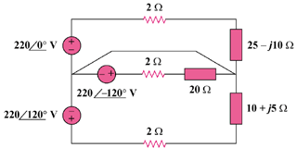

440∠0˚ V

440∠120˚ V

440∠–120˚ V

Figure 12.43
For Probs. 12.10 and 12.58.

